Title: Online Hotel Room Booking System
Aim
To develop a responsive hotel booking website that allows users to search room availability, book or cancel rooms, manage profiles, and view booking history, while administrators manage rooms, prices, and bookings.
Algorithm
- Start the application.
- Allow users to register and log in.
- Search for rooms by dates and number of guests.
- Check room availability and display room details and prices.
- Allow users to book rooms and view booking history.
- Allow users to modify or cancel bookings at least 3 days before arrival.
- Allow administrators to manage rooms, prices, bookings, and website information.
- Display booking details and confirmation.
- Stop the application.
HTML Code

<!DOCTYPE html>
<html lang="en">
<head>
<meta charset="UTF-8">
<meta name="viewport" content="width=device-width, initial-scale=1.0">
<title>Hotel Room Booking</title>
<style>
body {
font-family: Arial, sans-serif;
margin: 0;
background: #f2f5f7;
color: #333;
}
header {
background: #164e63;
color: white;
text-align: center;
padding: 20px;
}
nav {
background: #083344;
padding: 12px;
text-align: center;
}
nav a {
color: white;
margin: 12px;
text-decoration: none;
}
main {
max-width: 750px;
margin: 25px auto;
padding: 20px;
background: white;
border-radius: 10px;
}
input, select, button {
width: 100%;
padding: 10px;
margin: 8px 0;
box-sizing: border-box;
}
button {
background: #0e7490;
color: white;
border: none;
cursor: pointer;
}
.room {
background: #e6f4f7;
padding: 12px;
margin: 12px 0;
border-radius: 6px;
}
footer {
background: #164e63;
color: white;
text-align: center;
padding: 15px;
}
</style>
</head>
<body>

<header>
<h1>Welcome to Blue Sky Hotel</h1>
<p>Comfortable Rooms at Affordable Prices</p>
</header>

<nav>
<a href="#booking">Book Room</a>
<a href="#rooms">Rooms</a>
<a href="#contact">Contact</a>
</nav>

<main>
<section id="booking">
<h2>Book Your Stay</h2>

<form id="bookingForm">
<label for="guest">Guest Name:</label>
<input type="text" id="guest" required>

<label for="checkin">Check-in Date:</label>
<input type="date" id="checkin" required>

<label for="checkout">Check-out Date:</label>
<input type="date" id="checkout" required>

<label for="guests">Number of Guests:</label>
<select id="guests">
<option>1</option>
<option>2</option>
<option>3</option>
<option>4</option>
</select>

<label for="roomType">Room Type:</label>
<select id="roomType">
<option value="1500">Standard - ₹1500/night</option>
<option value="2500">Deluxe - ₹2500/night</option>
<option value="4000">Suite - ₹4000/night</option>
<option value="5000">Family Room - ₹5000/night</option>
</select>

<button type="submit">Check and Book</button>
</form>

<p id="message"></p>
</section>

<section id="rooms">
<h2>Our Room Types</h2>
<div class="room">Standard Room - ₹1500 per night</div>
<div class="room">Deluxe Room - ₹2500 per night</div>
<div class="room">Suite Room - ₹4000 per night</div>
<div class="room">Family Room - ₹5000 per night</div>
</section>

<section>
<h2>Hotel Information</h2>
<p>About Us: We provide comfortable accommodation for travelers.</p>
<p>Customer Service: Contact us for booking assistance.</p>
<p>Travel Guide: Ask our reception for local attractions.</p>
<p>Privacy Policy: Guest details should be kept private.</p>
</section>

<section id="contact">
<h2>Contact Us</h2>
<p>Email: bluesky@example.com</p>
<p>Phone: 9876543210</p>
</section>
</main>

<footer>
<p>&copy; 2026 Blue Sky Hotel</p>
</footer>

<script>
document.getElementById("bookingForm").addEventListener("submit", function(e) {
e.preventDefault();

const name = document.getElementById("guest").value;
const checkin = document.getElementById("checkin").value;
const checkout = document.getElementById("checkout").value;
const price = Number(document.getElementById("roomType").value);

const start = new Date(checkin + "T00:00:00");
const end = new Date(checkout + "T00:00:00");
const nights = (end - start) / (1000 * 60 * 60 * 24);

if (!checkin || !checkout || nights <= 0) {
document.getElementById("message").textContent =
"Please select valid check-in and check-out dates.";
return;
}

const total = nights * price;
document.getElementById("message").textContent =
"Booking request for " + name + " received! " +
"Nights: " + nights + ", Total: ₹" + total +
". This is a demo; no reservation or payment was processed.";
});
</script>

</body>
</html>
Output:
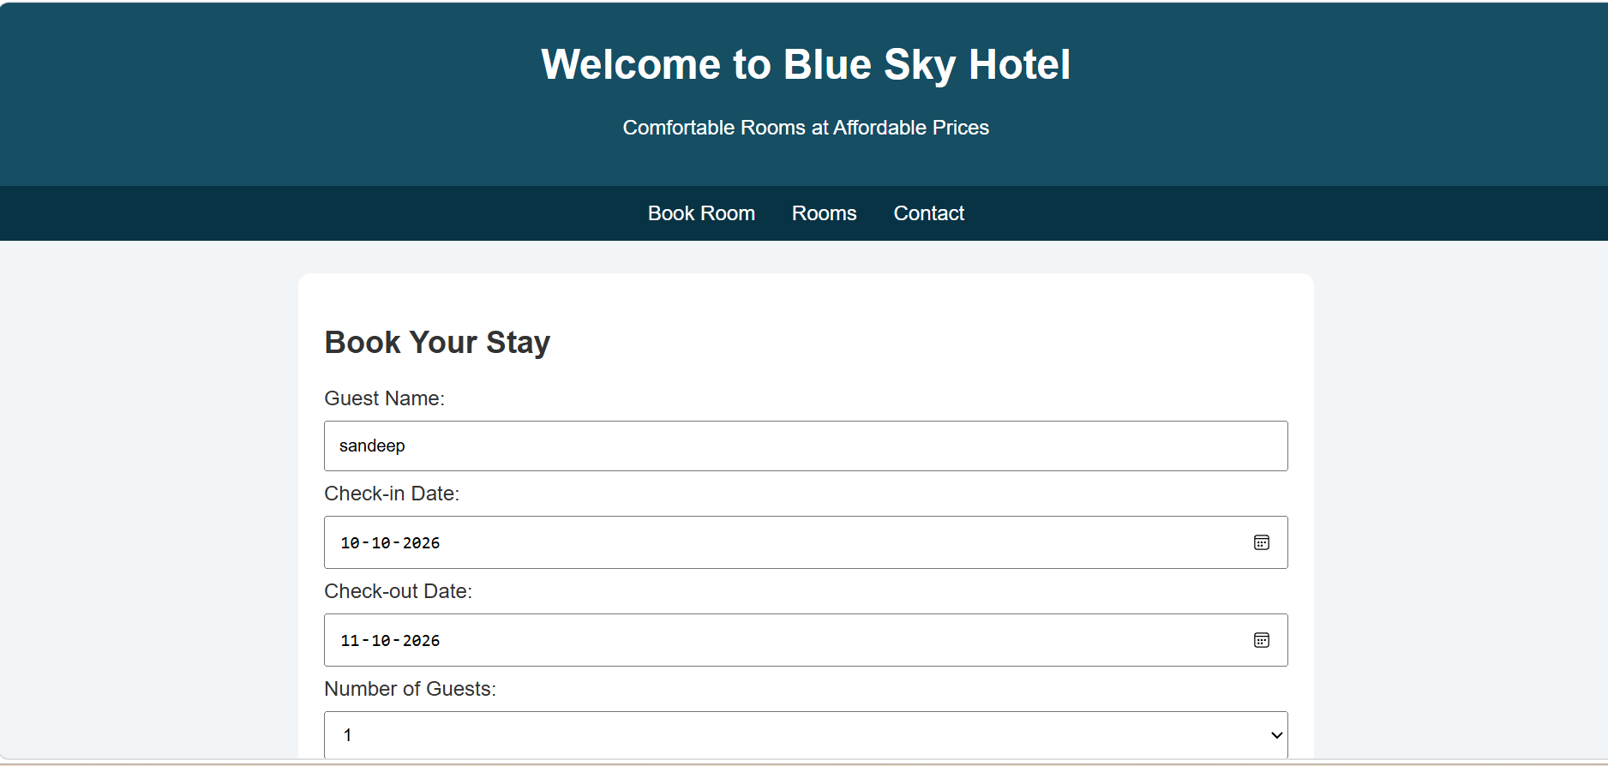

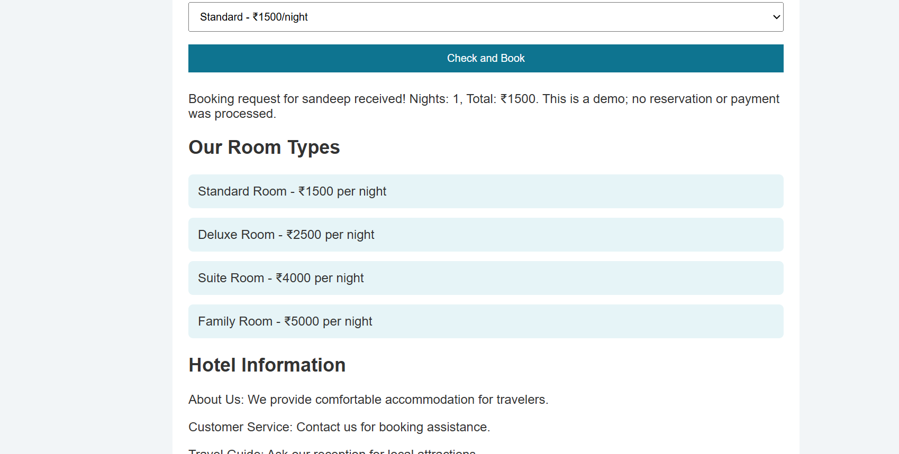
Result
The hotel booking webpage was created successfully. Users can select room types, enter check-in and check-out dates, and calculate the estimated room cost. The website also displays room information, hotel details, and contact information.

